**Customer Service Requests Analysis-Project 1**

DESCRIPTION

You've been asked to perform data analysis of service request (311) calls from New York City. You've also been asked to utilize data wrangling techniques to understand the pattern in the data and visualize the major types of complaints.

* Understand the dataset:

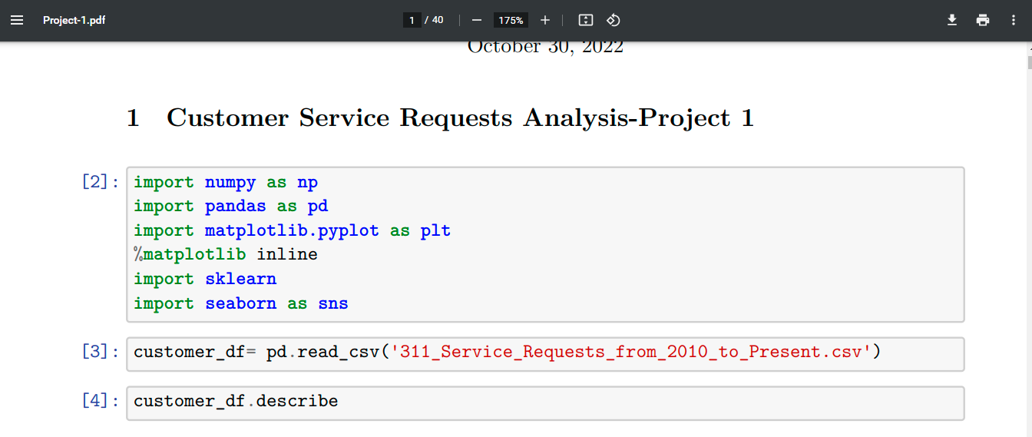

1. Identify the shape of the dataset

1. Identify variables with null values

* Perform basic data exploratory analysis:

1. Utilize missing value treatment

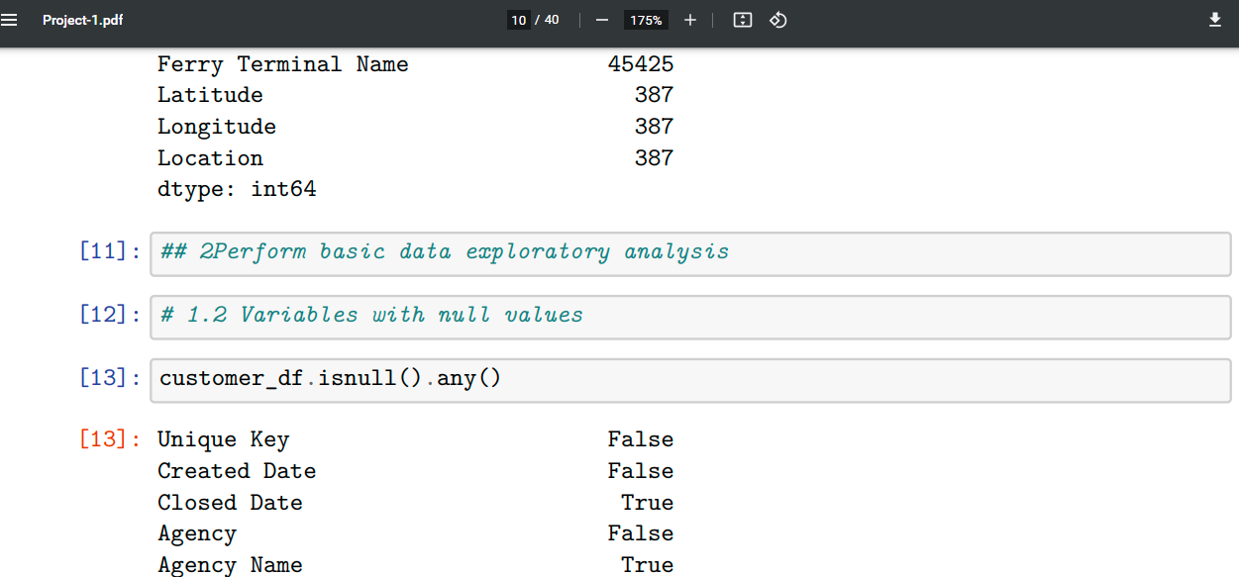

1. Analyze the date column and remove the entries if it has an incorrect timeline

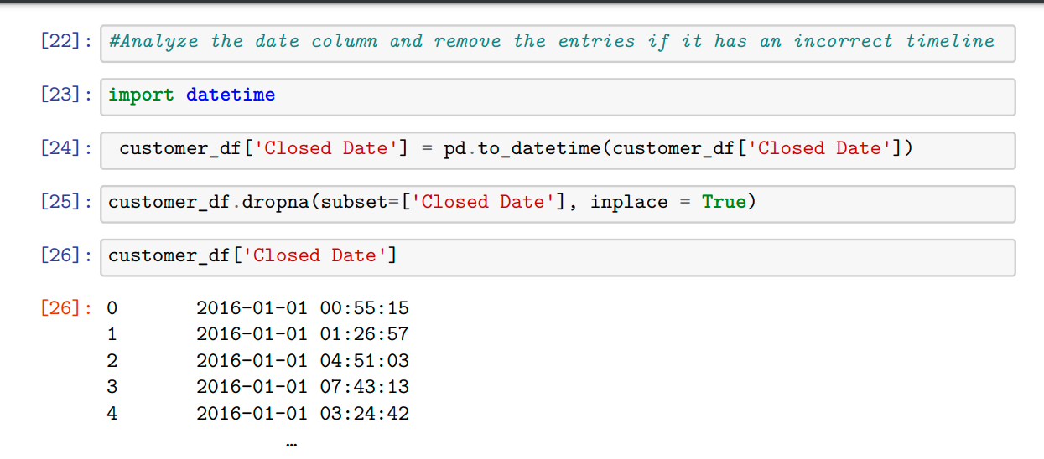

1. Draw a frequency plot for city-wise complaints

1. Draw scatter and hexbin plots for complaint concentration across Brooklyn

* Find major types of complaints:

1. Plot a bar graph of count vs. complaint types

1. Find the top 10 types of complaints

1. Display the types of complaints in each city in a separate dataset

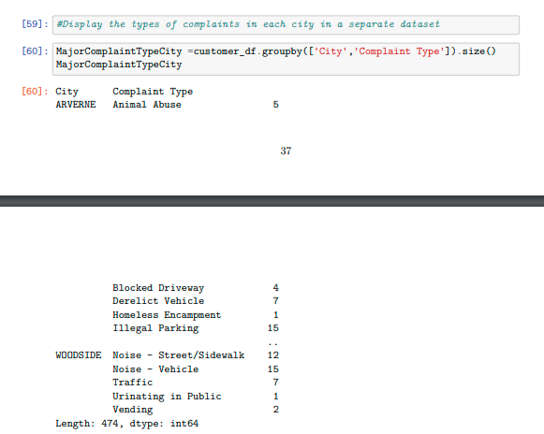

* Visualize the major types of complaints in each city

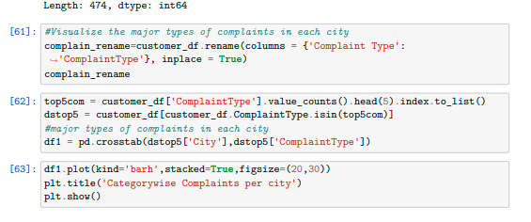

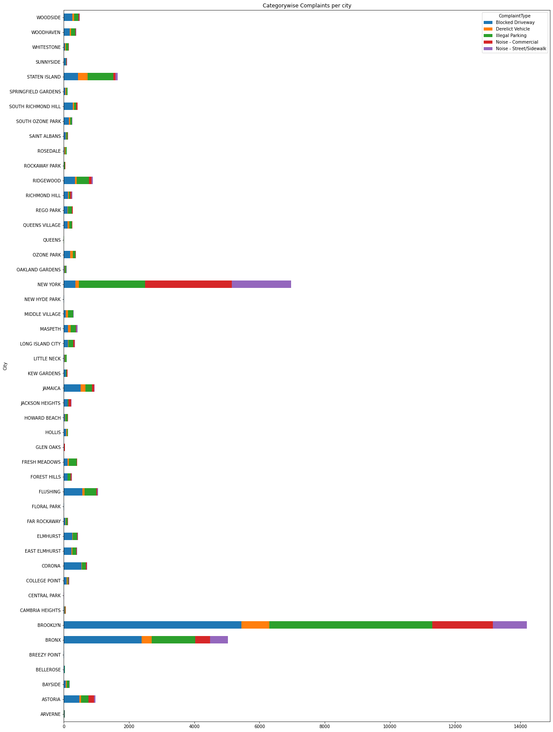

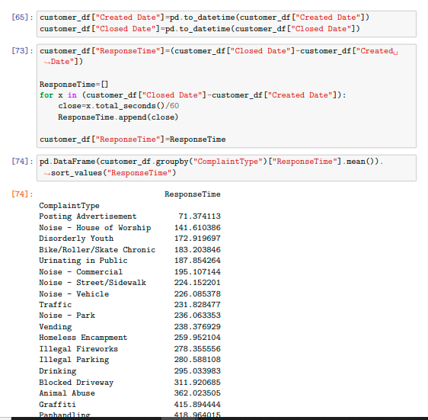

Project Code:



